Proposal for R&D towards a measurement of direct photon HBT with STAR
A.Chikanian, E. Finch, R. Majka, J. Sandweiss
Yale University

Feb 28, 2006

1. Overview
Because photons are produced in the earliest stages of a heavy ion collision and are emitted without any significant rescattering, the measurement of the direct photons spectrum is generally recognized as carrying critical information for the analysis of heavy ion collisions. Unfortunately, the background of photons from other sources (most notably π⁰ decays) is many times larger than the direct photon signal for transverse momentum under a few GeV/c, making a measurement very difficult.
One way of extracting a measurement is by using the fact that because the direct photons are emitted from a space time region a few fermis large, they will show an HBT correlation on a momentum scale of roughly 100MeV/c. Background photons are emitted from a vastly larger region and therefore show HBT correlations only on a much smaller (by a factor of ~10⁶) momentum scale. By measuring the HBT correlations, therefore, the spectrum of direct photons can in principle be disentangled from the total photon spectrum down to very low p_{T}.
Perhaps even more importantly, by measuring the HBT spectrum, we can gain space-time information about the photon emitting source which is quite sensitive to the temperature and space-time profile of the early collisions system. For this task, measuring the HBT correlations at transverse momentum near 1 GeV/c (where the direct photon spectrum is expected to be dominated by photons emitted from the QGP phase) is vital.
We present here a description of a R&D program that aims to make a measurement of direct photon HBT with STAR. From the work we have already done, our understanding is that this measurement is possible but difficult. We believe that the best way to make this measurement is to measure pairs of photons in which one of the photons converts to an e⁺e⁻ pair that is measured in the TPC and the other is measured in a calorimeter. This permits the resolution of photons with essentially zero opening angle. From our simulations thus far, we find that we will need to take a large amount of data using the current STAR detector with 2 critical changes:

- We will need for this dataset to install a photon converter of about 0.1 radiation length so that some photons are measurable in the TPC. The thickness is a trade off between having high conversion efficiency and having good resolution for the measurement of the electron-positron pair.
- We will need a calorimeter with improved energy resolution (on the order of 5%/√{E}) and good efficiency for photons down to around 100MeV of energy. From our initial investigations, we are hopeful that a calorimeter of the 'shashlyk' design may accomplish both of these goals at a reasonable price. There may certainly be other alternatives to this design and we are of course open to other designs which will have similar or better features.

The main R & D tasks that need to be done are:
- Continued simulation and analysis along the lines of what has been done already. In particular, as the calorimeter design becomes more clear, simulations will need to be improved accordingly. Also, analysis techniques may be improved to reduce some of the systematic difficulties with the analysis.

- Construction of prototype towers of a new calorimeter to be inserted into STAR. We envision this being of a shashlyk design and have had initial discussions with the designers of the shashlyk calorimeters for E865 and KOPIO, though again we are open to other possibilities.

2. Simulations

We will describe now the simulations we have done thus far and the results obtained from them.

Detector efficiency and resolution.

To estimate the TPC detection efficiency and resolution for photons which are converted in a 10 % radiation length converter in front of the TPC, an additional GEANT simulation has been performed. We show an event display with single photon, converted in the radiator, in Figure 1.
Results of the calculation of efficiency and angular resolution are presented in Figure 2a,b,c and for momentum resolution in Figure 3.

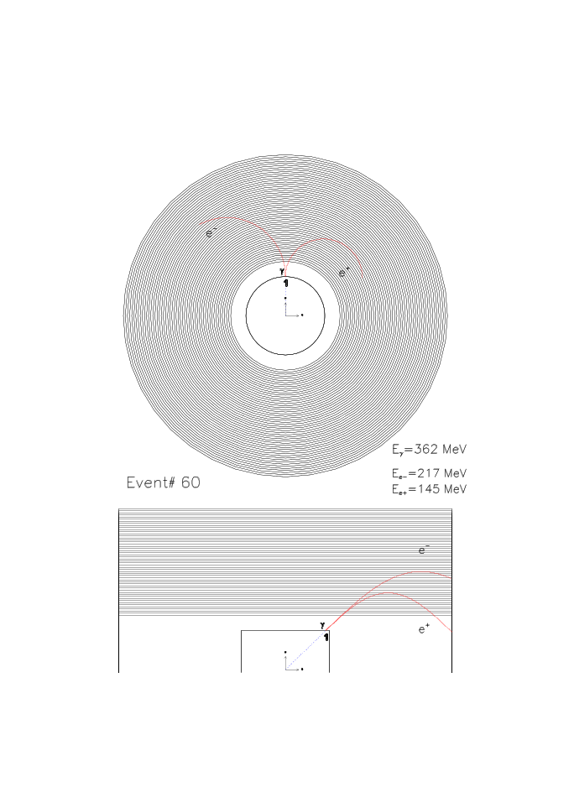
Figure 1. Example of a single photon conversion event. A photon (E=362MeV) is converted in the 0.1 rad. length converter which has radius=45cm and length=1m

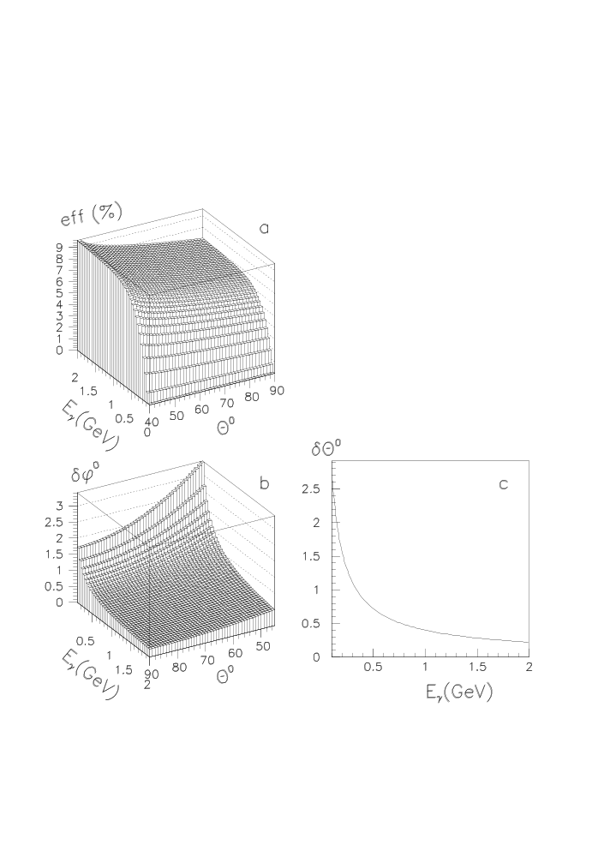
Figure 2. TPC efficiency(a), and azimuthal(b) and polar angle(c) resolutions

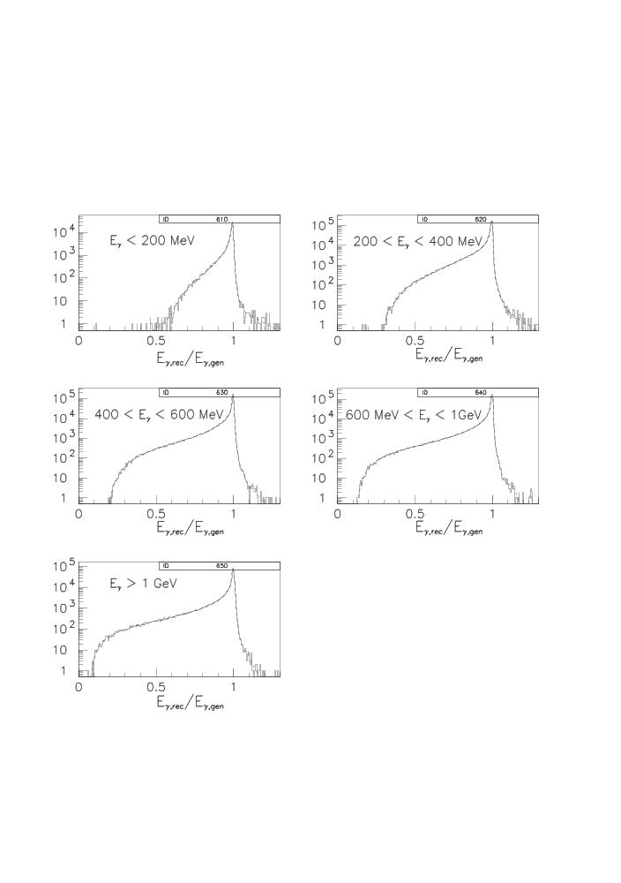
Figure 3. TPC photon energy resolution. The distributions of ratios of reconstructed energy to true photon energy are shown for 5 different energy ranges. The long shoulders on the left of the peaks are due to bremstrahlung in the converter.
For the EMC we have assumed a “shashlyk”-type calorimeter, similar to the one designed for the KOPIO experiment [1] with the following major parameters:

Granularity: ~ 10 cm.
Moliere radius: ~ 6 cm.
Energy resolution: ΔE/E ≈ 3% / √ E(GeV).
Detection efficiency: ε > 99 % at E > 50 MeV.
Angular resolution: Δθ = Δφ = 10 mrad.

We have then tried to account for loss of efficiency due to charged particle showers and overlapping showers with the following additional procedures:

1) Our simulation with HIJING events showed that this EMC will experience on average a 43 % occupancy by charge particles. To take this fact into account we just assumed that EMC efficiency would be 57 % instead ~ 100 %.
2) In any EMC there is a limit for the recognition of overlapping photons showers which depends mostly on the Moliere radius and calorimeter granularity. We assumed that all photons with energy below 100 MeV and closer than ¾ Moliere radius to any photon with energy higher than 100 MeV are just merged into one photon.
The remaining low energy photons (< 100 MeV) are ignored. If two or more high energy photons (E>100MeV) are closer to each other than 1.5 times the Moliere radius, those photons are excluded from the analysis under the assumption that it most of such cases we will be able to identify showers which contain two photons.

We understand that a true calorimeter’s performance will be more complex, but we aim only to model the gross features here.

Physics Input

We assume two sources of photons: Direct photons and photons from π⁰decay. The π⁰ spectrum is taken from PHENIX(for p_{T} dependence) and PHOBOS (for rapidity dependence) data, giving the spectrum shown in Figure 4.
For direct photons, we need to model the complete space-time source structure as well as the momentum spectrum and we have constructed the following simple model: We assume that there are three 'eras' of direct photon generation (corresponding, roughly, to (1) initial hard scattering, (2) QGP production, and (3) hadron gas production.) We fit the temperature components of these three eras to give an overall spectrum matching the prediction given in [2]. With this temperature evolution as a function of proper time (shown in Figure 5 top), we assume that there is a Bjorken longitudinal expansion of the source and that each piece of matter emits direct photons with a Boltzmann p_{T} spectrum corresponding to the temperature at its proper time. We assume a transverse size of 3 fm with, for simplicity, no transverse expansion. The resulting p_{T} spectrum is shown in Figure 5 bottom panel along with the spectrum from [2]. The p_{T} and rapidity spectra are also shown on the lower panels of Figure 4 to permit comparison with the input spectrum of π⁰ decay photons. (The rapidity spectrum of direct photons was taken from [3], but because our assumed acceptance is roughly from -1 to +1 in rapidity, our results are very insensitive to this shape)
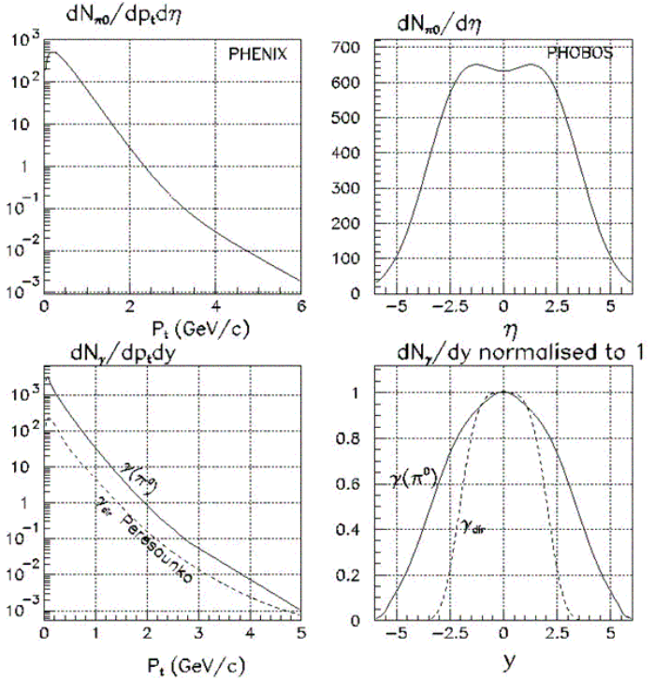
Figure 4 The top two panels show the distributions of neutral pions used in our simulation and taken from PHENIX and PHOBOS measurements. The bottom panels show the resulting spectrum of photons with the spectrum of direct photons overlayed for comparison.
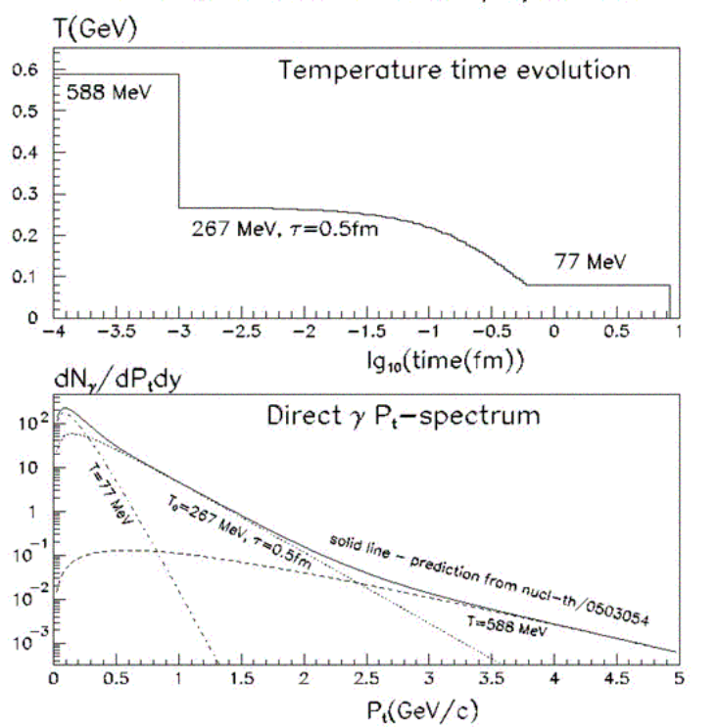
Figure 5 Top panel shows the temperature evolution as a function of time for our simple model of direct photon production. The resulting spectrum is shown in the lower panel along with the spectrum from nucl-th/0503054 which the temperature parameters were adjusted to fit.
To the direct photons then must be added an HBT correlation. This correlation is added not in the generator itself but as pair-by-pair weights calculated when the correlation function histograms are formed. To be slightly more explicit, the two-particle correlation function C₂ = P(k₁,k₂)/(P(k₁)·P(k₂)) , can for HBT correlations be written (after some assumptions [4-6]) as C₂ = 1 + λ₀ < Cos(ΔQ∙ΔR) >, with the average being taken over all direct photon pairs with ΔQ∙ΔR = (ΔE∙Δt-ΔP_{x}∙Δx-ΔP_{y}∙Δy-ΔP_{z}∙Δz), and λ₀ = ½ for massless spin 1 photons. We then calculate the momentum space correlation function experimentally as the ratio of pairs found in ‘same events’ to pairs found in ‘mixed events’. Each mixed event pair is given a weight of w = 1. Each same event pair is given a weight of w = 1 + λ₀∙Cos(ΔQ∙ΔR) if the pair is formed from 2 direct photons, and w = 1 if at least one of the photons is a decay photon. Then in terms of the same and mixed event histograms, C₂ = Same/Mixed.
Also, it should be noted that in our simulation we artificially assign λ₀ to 1, which allow us to generate four times fewer events to see a signal of a given statistical significance.

- Simulation Results
Definitions of Observables

First, we will list various formulations of the momentum difference, Q
Q²_{inv} = 2·( |P₁|·|P₂| - (P₁·P₂) ) = 4·E₁·E₂ ∙Sin²(θ/2 )

Q²_{osl} = Q²_{out} + Q²_{side} + Q²_{long}

Q_{out} = (P²_{tr1} - P²_{tr2}) / P_{tr}, where P_{tr} = | P_{tr1}+P_{tr2}| - pair transverse momentum
Q_{side} = 2· | P_{tr1}×P_{tr2} | / P_{tr}
Q_{long} = γ_{z}·((P_{z1}-P_{z2}) + β_{z}·(E₁-E₂)), γ_{z} , β_{z} – correspond to the reference frame,
where P_{z}^{pair} = (P_{z1}+P_{z2}) = 0.

Q²_{xyz} = Q²_{x} + Q²_{y} + Q²_{z ,} Q_{x}=P_{x1}-P_{x2} , Q_{y}=P_{y1}-P_{y2} , Q_{z}=P_{z1}-P_{z2}

If statistics permit, the most complete analysis is done as a full 3-D fit to Q_{out}, Q_{side} and Q_{long} as a function of pair transverse momentum (k_{T}) or separate 1-D fits to slices in the various components.. Where statistics are more limited, we will make do with one of the 1-D variations of Q. Among these, the often used Q_{inv} is somewhat difficult to use because it can be zero when the full Q vector is nonzero, and this effect is more pronounced for photons than for massive particles due simply to kinematics. Results as a function of Q_{osl} and Q_{xyz} are easier to interpret.

Results with direct photons only

We show in Figure 6 the results of our simulations with direct photons only (i.e. no background from π⁰ photons) for the detectors having their nominal resolution and also perfect resolution. From such a 3-D analysis, we can (albeit in a somewhat model dependent way) extract the relationship between the space-time extent of the source and the source temperature. Particularly notable in this case is the strong dependence of R_{long} on p_{T}, with the very small value at p_{T}>600MeV/c reflecting a small longitudinal source dimension at the time when photons of this momentum are mainly produced.
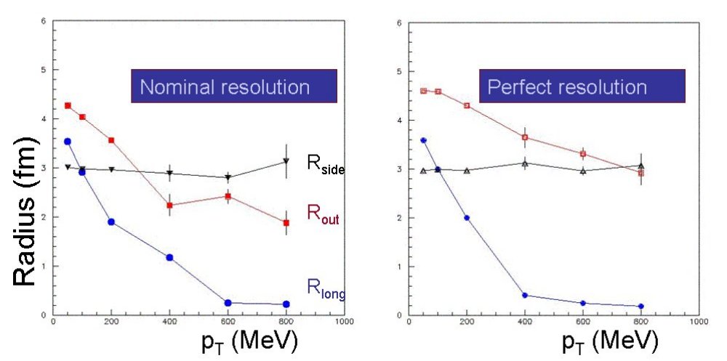
Figure 6 Radius parameter R_{out}, R_{side} and R_{long} extracted from an HBT analysis of direct photons (with no pion decay background) produced from our simple source model.

Full Simulation Results

Adding the π⁰ background of course makes the extraction of measurements much more difficult, both by requiring many more statistics to overcome this large background and also by adding the correlation structure of the π⁰ mass peak which sits not far from the HBT peak itself. We have found that the presence of the π⁰ mass correlation may also interact with our calorimeter isolation cuts to produce structure near Q_{inv}=m_{inv} = 0 with a magnitude of around 1/3 of the HBT peak. This structure may complicate the HBT results in any Q observable. We have removed this extra structure in our analysis by adding extra fake photons to the calorimeter in our mixed event analysis that are correlated by the π⁰ mass peak to some appropriate TPC photon. This technique removes this low-Q structure and also reduces by a factor of a few the magnitude of the structure due to the π⁰ mass peak itself. This is a helpful technique which we believe can be implemented in real data analysis, but the analysis could proceed without it.
We show results from the complete simulation corresponding to 80×10⁶ events in Figure 7 and Figure 8. Figure 7 shows the results of the correlation function over the entire k_{T} spectrum for slices of Q_{out}, Q_{side} and Q_{long} (with slices of ±10MeV in the other Q components) as well as one dimensional correlation functions on Q_{inv}, Q_{osl}, and Q_{xyz}. (In subsequent plots, we will show only Q_{osl} since Q_{inv} behaves in undesirable ways and Q_{xyz} is quite similar to Q_{osl}). Clearly, there is a generous signal in every plot for the full k_{T} spectrum. In Figure 8, we show the correlation function divided into k_{T} bins of k_{T} <400MeV/c, 400<k_{T}<800MeV/c, and k_{T}>800MeV/c Clearly, extracting a signal in this highest k_{T} bin will require more statistics as shown in the following figures.

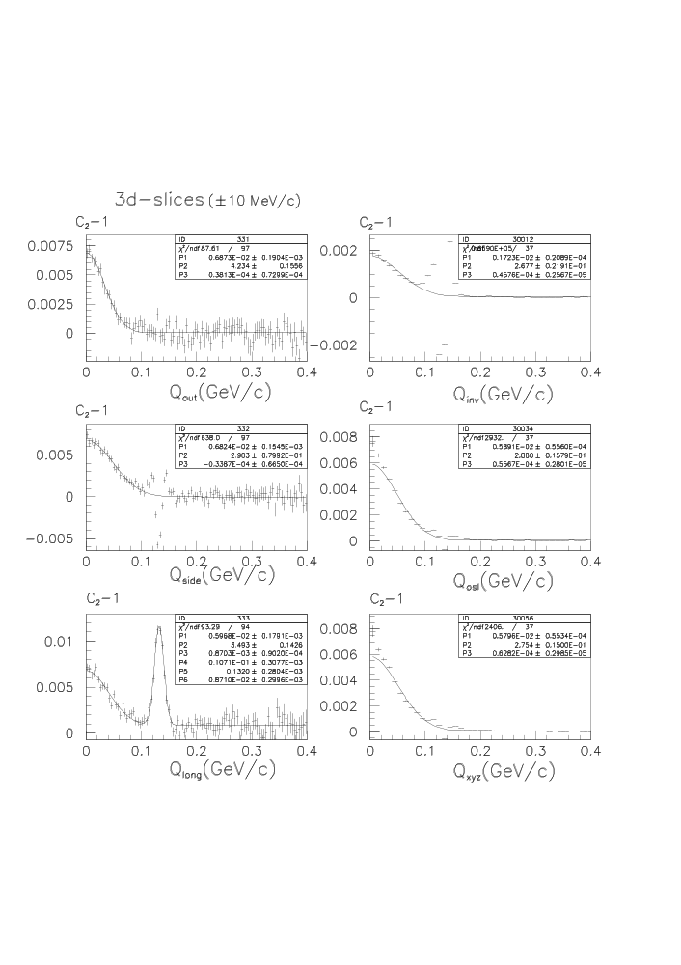
Figure 7. Correlation function (C₂-1) for 20 million simulated events (statistaically equivalent to 80 million central STAR events). Panels on the left hand side are slices in Q_{out}, Q_{side} and Q_{long}. Panels on the right hand side are one dimensional fits to Q_{inv}, Q_{osl}, and Q_{xyz}.
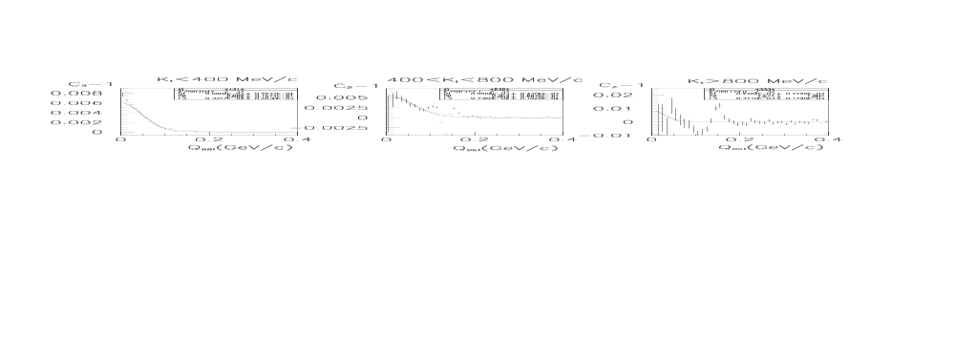
Figure 8. Correlation function (C₂-1) for 20 million simulated events (statistically equivalent to 80 million central STAR events) for three different ranges of pair k_{T}.

The correlation function for k_{T}>800MeV/c for a full simulation of the equivalent of 4×10⁹ events is shown in Figure 9. This is a critical momentum range to measure because at this tranverse momentum the direct photon spectrum should be dominated by photons from the QGP. As can be seen from Figure 9, extracting a signal in this region will be difficult even with such a large data sample. It is possible that better analysis techniques may yield an improved result and certainly such a critical measurement warrants a great deal of effort. Some hope for this is provided by Figure 10, which shows the difference between the plots of Figure 9 and those same plots with HBT correlations turned off (i.e. only the HBT correlations should remain in Figure 10). The fit parameters from these plots are similar to those shown in Figure 9.
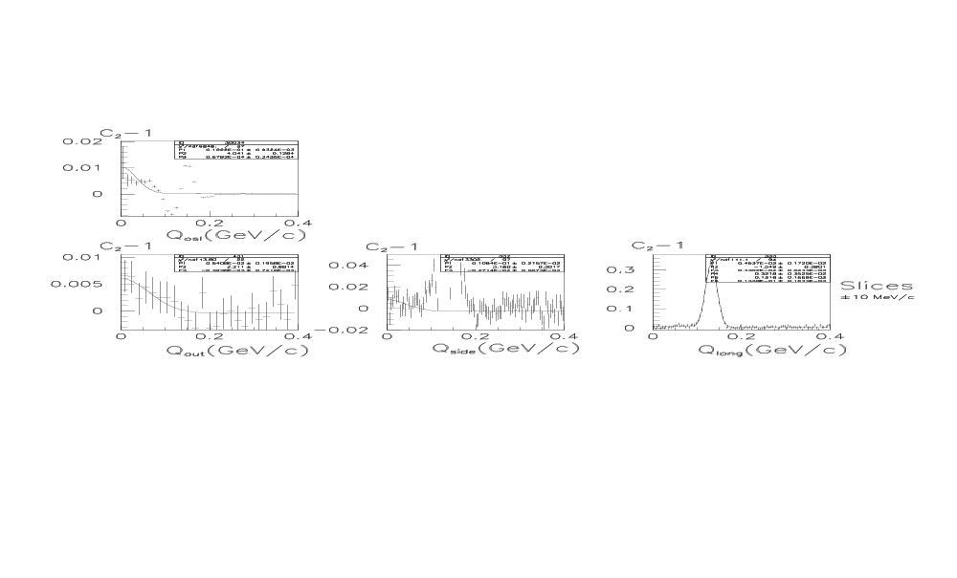
Figure 9. Correlation function (C₂-1) for 1.1 Billion simulated events (statistically equivalent to 4.4 Billion central STAR events) for pairs with k_{T} in the range k_{T}>800MeV/c. The top panel shows the correlation function versus Q_{osl}, and the bottom three panels show slices in Q_{out}, Q_{side} and Q_{long}.
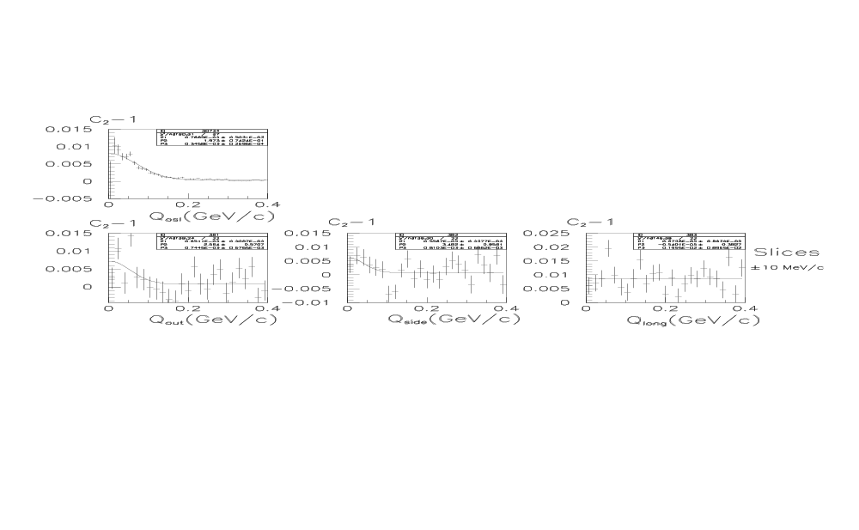
Figure 10. The difference between the correlation functions shown in Figure 9 and the correlation functions with HBT correlations turned off. The resultinghistograms, shown here, should differ from zero only by the HBT correlations.

Residual Correlation from π⁰ HBT

Another possible systematic problem is the correlation between photons that come from decays of different π⁰s due to the HBT correlation between the parent π⁰s . We have investigated this correlation with further simulations and have concluded that this correlation in small enough that it will not be a significant problem for the direct photon HBT measurement.

4. Calorimeter Research and Development

The direct photon HBT program requires a calorimeter with good efficiency for photons with energies down to 100MeV, and with better energy resolution than the present STAR calorimeter provides. The current STAR calorimeter is basically designed for “high” energy photons and reaches full efficiency only for photons with energies above roughly 800 MeV.
From past experience (E-865 at the AGS and work for the KOPIO experiment) it appears that a shashlyk design is capable of good efficiency down to 50 MeV and resolution in the range of 3% to 5%. We wish to start an R&D program to develop such a calorimeter for STAR.
This program would have 2 phases:
- A design and simulation phase. Here we would consult with the E-865 and KOPIO physicists to learn about their simulation tools. We would then carefully study the problem and ultimately produce a design which should then be prototyped.
- Construction and test of a some small number (at least 2) towers of a prototype. We envision that this would be constructed in such a manner that it could be mounted in STAR in place of one module of the current calorimeter for testing purposes.

Clearly this should involve a group of STAR colleagues beyond just our Yale group. Hopefully this proposal will allow us to form such a group.
The design phase does not require any additional funding, but would require additional interested STAR collaborators. The prototyping phase would require funds to construct two towers for test evaluation. An accurate estimate of the cost must await the formation of the working group and the evaluation of the resources available. However, we know from past experience (e.g. our construction of the E-864 calorimeter at the AGS) that an approximate estimate of the needed funds is $50,000.

5. Conclusion

The simulation results presented in this paper show that with the STAR upgrade outlined here, measuring the HBT correlations from photons with an upgraded STAR detector is an achievable goal and would provide extremely interesting information on the direct photon yield and more importantly on the relationship between the space-time extent of the source and the source temperature. Measurement of the HBT correlation at low p_{T} should be easily achievable with the upgrades we have outlined in this proposal.
Perhaps the most interesting information that we may hope to extract is the source dimensions during the QGP phase, and this will require a measurement of photon HBT at k_{T} of around 800 MeV/c. This measurement will be difficult with the envisioned upgrades but may be possible and the interest of such information surely warrants further study.

References
- G.S. Atoiyan et. al. “Development of Shashlyk calorimeter for KOPIO”, NIM A 531 (2004)
- D. d’Enterria and D. Peressounko/nucl-th/0503054
- S.Y. Wang, D. Boyanovsky, K.W. Ng. Nucl Phys. A699, 819 (2002)
- M. Podgoretsky “Interference correlations of identical pions. Theory”, Physics of Elementary Particles and Atomic Nuclei, 20 , part 3 (1989).
- S.A. Bass, B. Muller, D.K. Srivastava. “Photon Interferometry of Au+Au collisions at RHIC”, Phys. Rev. Lett 93, 162301, 2004
- G.I. Kopylov. Phys Lett. 50B, 4 (1974)

